**Operation Manual**

**EFT Transmission to Edge Node**

*Ascena Brands*



Table of Contents

1 Document Revision History 4

2 Program Overview 5

2.1 Overview 5

2.2 Overview of Functionality and Key Processes 5

2.2.1 Transmission of Files to Edge Node 5

2.2.2 File Hygiene Processes 5

2.3 Contributing Applications and Services 5

2.4 Scheduled Events 6

2.5 Infrastructure and Design 7

2.5.1 Process Flow Diagram 7

2.5.2 File and Data Orchestration 11

3 Security and Access Control 14

4 Program Configuration 15

5 Configuration Management 15

5.1 Code Repository 15

5.2 Backup and Restore Procedures 15

6 Monitoring and Alerting 16

6.1 Daily Operational Monitoring and Alerting 16

6.2 Error Messages 16

6.3 Health Checks 16

7 Operational Tasks 18

7.1 Deployment 18

8 Failure and Recovery Procedures 18

8.1 Troubleshooting 18

9 Contact Details 18

10 Additional Document References 19

11 Appendix 20

Table of Figures

Figure 1 - Scheduled Events Example 6

Figure 2 - Process Flow Diagram 7

Figure 3 - Process Flow - Transfer to EFT Server 8

Figure 4 - Process Flow - EFT Transfer to Hygiene 9

Figure 5 - Process Flow - Hygiene Job 9

Figure 6 - Process Flow - EFT to EDL Edge Node 10

Figure 7 - Process Flow - EDL TWS Job 11

Figure 8 - File and Data Orchestration 11

Figure 9 - File and Data Orchestration - Source Files 12

Figure 10 - File and Data Orchestration - Transfer to EFT Server 12

Figure 11 - File and Data Orchestration - Hygiene Decision 13

Figure 12 - File and Data Orchestration - EFT Transfer to Hygiene 13

Figure 13 - File and Data Orchestration - Hygiene Job 13

Figure 14 - File and Data Orchestration - EFT to EDL Edge Node 14

Figure 15 - File and Data Orchestration - EDL TWS Job 14

Figure 16 - Example of Management Dashboard 17

Figure 17 - Example of Management Dashboard Drill In 17

Table of Tables

Table 1 - Configuration Options 15

# Document Revision History

| Date | Author | **Revision Description** |
| --- | --- | --- |
| 2019/09/11 | George Brown | Initial Version |
| 2019/09/17 | George Brown | Finalized version for review |
| 2019/09/17 4:42 PM | George Brown | Added link for “EFT Transmission to Edge Node - Control-M Job Setup Requirements.xlsx” |
| 2019/09/18 | George Brown | Updated based on initial review with team. |
| 2019/11/18 | George Brown | Updated links to external documentation |

# Program Overview

## Overview

|  |  |
| --- | --- |
| **Purpose** | All data feeds into the EDL (enterprise data lake) initially land on the edge node before ingestion and the files are transmitted by EFT jobs.  Each file travels through a few different paths prior to landing on the edge node depending on its source, its format and data content. However, each file at the very least goes through a final EFT job that transmits to the edge node.  Once the files are on the edge node, then the next steps of the data flow process will take over and ingest into the data lake (those downstream processes are NOT covered in this document). |
| **Document Scope** | This operation manual will contain documentation regarding the core components of EFT transmission to the Edge Node for all files (all brands). Documentation on proceeding or succeeding processes or programs will not be included in this operation manual. However, proceeding or succeeding documentation may be referenced. |

## Overview of Functionality and Key Processes

### Transmission of Files to Edge Node

In order to ingest any data into the EDL, files must be transmitted to the EDL edge node. Once on the edge node, downstream processes (fully documented in subsequent manuals) ingest the data into the staging database in Hive.

### File Hygiene Processes

Some files may need to go through custom hygiene processes to prepare them for ingestion into the staging database in Hive. These hygiene processes include, but are not limited to, file splitting by record type, file renaming, file type conversion or asci conversion. Please see the full operation manual on hygiene processes for further information.

## Contributing Applications and Services

Transmission of data feeds to the Edge Node use the following applications and services.

* EFT Jobs – Every file has at least one associated EFT job to transmit to the EDL edge node. However, depending on the file’s source, format and data content, there may be multiple associated EFT jobs. These jobs are maintained and monitored by the Ascena EFT team.
* Control-M Jobs – These jobs may be used in a few different paths for file transmission. First, Control-M jobs may be used to initially transfer the file to the EFT servers when the source of the data is internal to Ascena. Second, Control-M jobs may be used to execute hygiene processes if required by the file. These jobs are maintained by the Ascena production control team and monitored by the Ascena operations team.
* Hygiene Processes – Some files need to go through hygiene processes before they can be ingested into the EDL. These hygiene processes are executed using Control-M jobs.
* Encryption Keys – Most, if not all, sources send files to the EFT server encrypted with the Ascena EFT key. Before these files are sent to the EDL they are decrypted and then encrypted with the EDL key (provided by the ascsftp service account). Encrypting the files before sending to the edge node is standard process regardless of the data content or transmission method.

## Scheduled Events

The “EFT Transmission to Edge Node - File and Data Orchestration.xlsx” spreadsheet (linked later in document) will provide schedules for all jobs and events by file name. **NOTE:** Unless otherwise noted, all times are in EST and all frequencies are daily.

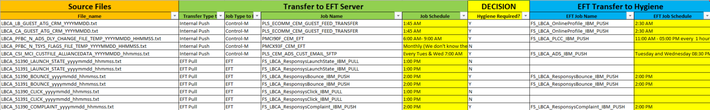

Figure - Scheduled Events Example

## Infrastructure and Design

### Process Flow Diagram

The “EFT Transmission to Edge Node - Process Flow Diagram.vsdx” diagram (link included later in this document) shows the steps a file takes in order to land on the EDL edge node in preparation of ingestion to the staging database in Hive. See the following bullet points to understand how to use this diagram effectively.

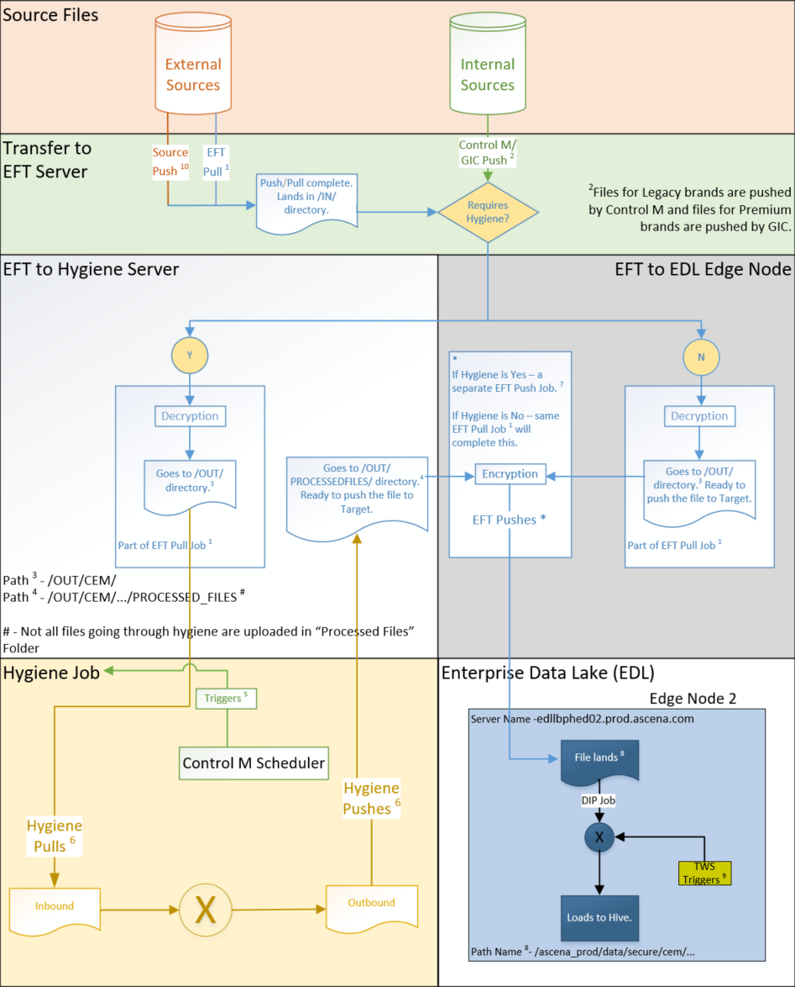

Figure - Process Flow Diagram

#### Source Files

In this diagram, files originate from either external or internal sources. Each type has a different path to the edge node. Most, if not all, source files are encrypted prior to transmission to the EFT server.

#### Transfer to EFT Server

External source files can be pushed to the EFT server from the source system (Ascena’s recommendation) or be pulled by Ascena EFT jobs (only in the event that the source system has no way to push).

Internal source files can be pushed to the EFT server from the source system.

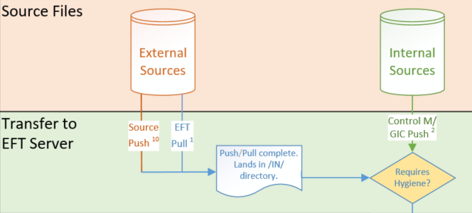

Figure - Process Flow - Transfer to EFT Server

#### Hygiene Decision

Some files need to go through hygiene processes before they can be ingested into the EDL.

#### EFT Transfer to Hygiene

If a file requires hygiene, an EFT job will run to decrypt the source file and move it to the OUT directory on the EFT server.

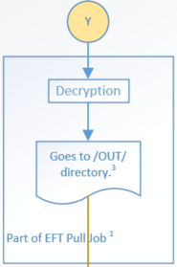

Figure - Process Flow - EFT Transfer to Hygiene

#### Hygiene Job

Hygiene jobs use Control-M for scheduling and execution. Once run, they will pull the decrypted source file over the to the hygiene server, run the processes internally, and then move the file out to a PROCESSEDFILES directory on the EFT server.

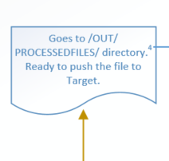

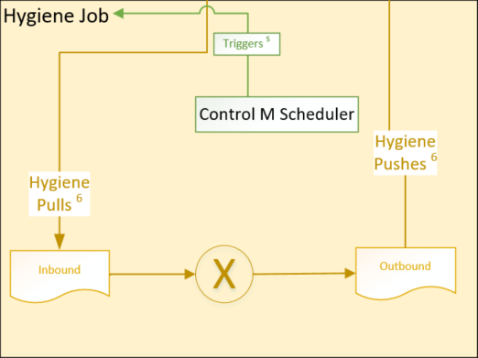

Figure - Process Flow - Hygiene Job

#### EFT to EDL Edge Node

All source files are ultimately sent to the EDL edge node using an EFT job. The inbound to this job depends on if the file has gone through hygiene or not.

If the file goes through hygiene, then the EFT job picks the file up from the PROCESSEDFILES directory on the EFT server, encrypts it with the EDL key, and then transmits to the edge node.

If the file doesn’t go through hygiene, the EFT job decrypts the file from the source, encrypts it with the EDL key, and then transmits to the edge node.

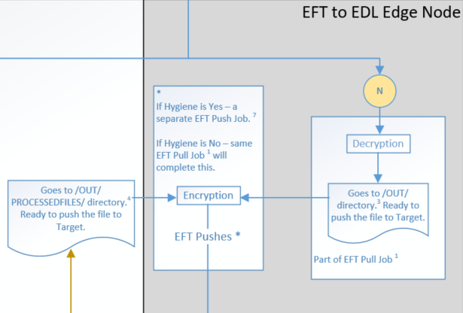

Figure - Process Flow - EFT to EDL Edge Node

#### EDL TWS Job

Source files are then ingested into the staging database in Hive using IBM TWS jobs. These jobs are included in the referenced documentation only as a link between transmission to the edge node and ingestion into the staging database; this document will not include detailed information regarding these jobs.

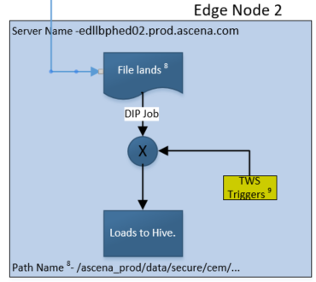

Figure - Process Flow - EDL TWS Job

### File and Data Orchestration

The “EFT Transmission to Edge Node - File and Data Orchestration.xlsx” spreadsheet contains the detailed list of source files and their associated EFT, Control-M and TWS jobs. The color coded sections of the spreadsheet correspond to the color coded sections of the process flow diagram to help in understanding the path each file takes to land on the edge node. These two documents are intended to be used together to fully support EFT transmission to the EDL edge node.

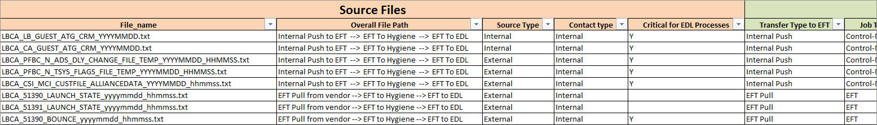

Figure - File and Data Orchestration

#### Source Files

The light orange color coded section of this spreadsheet provides information for the source file. This includes the file name, the overall file path (as visually represented in the process flow diagram), and an indicator for “Critical for EDL Processes”. **NOTE:** This indicator identifies the source files that contain data used in critical downstream processes. This may include providing data for Ascena’s loyalty programs, loading data into the EDL conform layer, or loading data into data marts for downstream consumption. These files take precedence and should be loaded / investigated first before others.

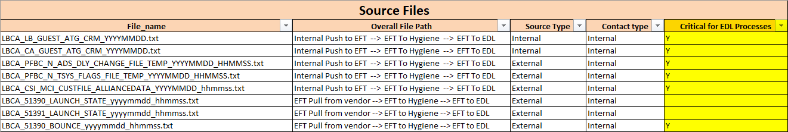

Figure - File and Data Orchestration - Source Files

#### Transfer to EFT Server

The light green color-coded section of this spreadsheet provides information for the jobs used to initially transfer the source files to the EFT server. As noted from the process flow diagram, source files can be transmitted to the EFT server in a few different ways.

* The column titled “Transfer Type of EFT” will provide the method used to initially transfer the source file to the EFT server.
* The column titled “Job Type of EFT Server” will provide the job type (EFT, Control-M, or source / vendor job)
* The column titled “Job Name” will provide the job name if know (source / vendor job names may not be known as they are not owned by Ascena)
* The column titled “Job Schedule” provides the frequency and time of the job (Daily frequency is assumed unless otherwise specified, EST is assumed unless otherwise specified)
* Other columns are included such as contact details and initial EFT server path

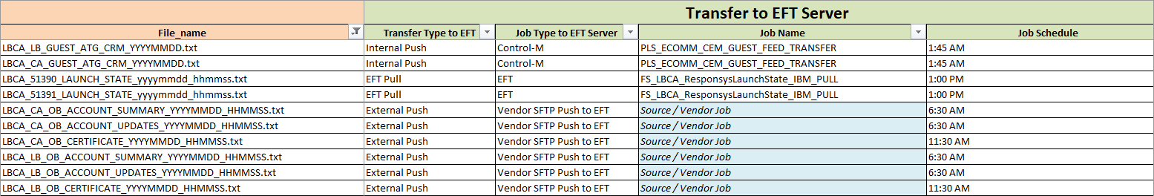

Figure - File and Data Orchestration - Transfer to EFT Server

#### Hygiene Decision

The yellow color-coded section of this spreadsheet notes if the file needs to go through hygiene or not. If not, then the “EFT Transfer to Hygiene” (Blue color-coded) and “Hygiene Job” (light orange color-coded) sections will be empty.

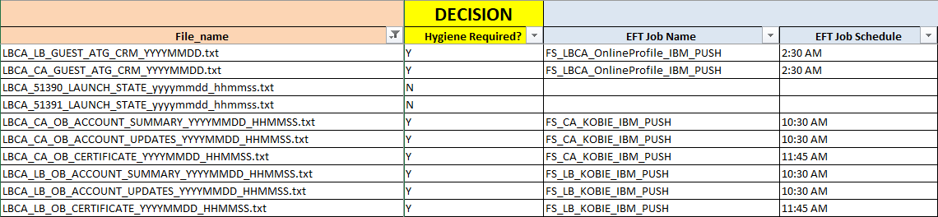

Figure - File and Data Orchestration - Hygiene Decision

#### EFT Transfer to Hygiene

The light blue color-coded section of this spreadsheet includes the EFT jobs used to decrypt the source files and send to the location where Hygiene jobs will pull from. Job details will be empty if the file does not require hygiene. Details include the EFT job name, schedule and outbound path (where Hygiene job will pick the file up from).

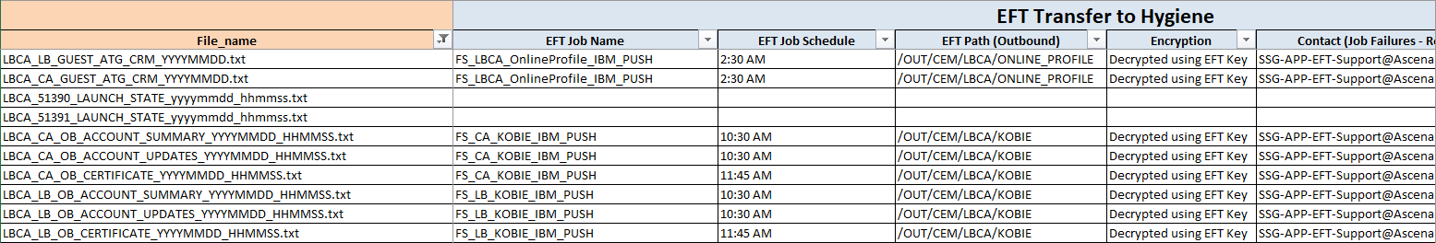

Figure - File and Data Orchestration - EFT Transfer to Hygiene

#### Hygiene Job

The light yellow color-coded section of this spreadsheet includes the Control-M job information used to execute the necessary hygiene steps against the source file. Job details will be empty if the file does not require hygiene.

* The column titled “Hygiene Processes” provides the list of actions taken against the source file. This may include data masking, file splitting, file renaming or file format conversion.
* The column titled “Hygiene Script / Command” provides the actual script invoked by the Control-M job.

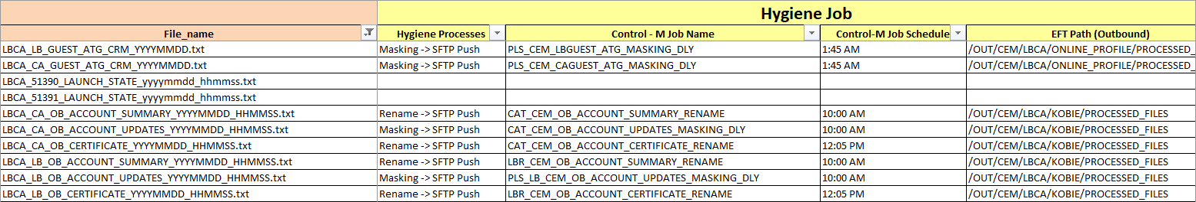

Figure - File and Data Orchestration - Hygiene Job

#### EFT to EDL Edge Node

They gray color-coded section of the spreadsheet includes EFT job details for the final transmission of the source files to the EDL edge node. All files will have job details in this section.

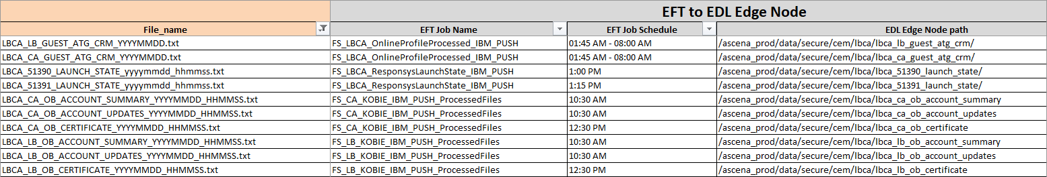

Figure - File and Data Orchestration - EFT to EDL Edge Node

#### EDL TWS Job

The tan color-coded section of the spreadsheet includes TWS job details for the ingestion of the source files to the staging database in Hive. These job details are included only to provide a link between this documentation and other documentation in the downstream data flow path. **NOTE:** The job schedule information in this section is in CDT but may be standardized to EST at a later point.

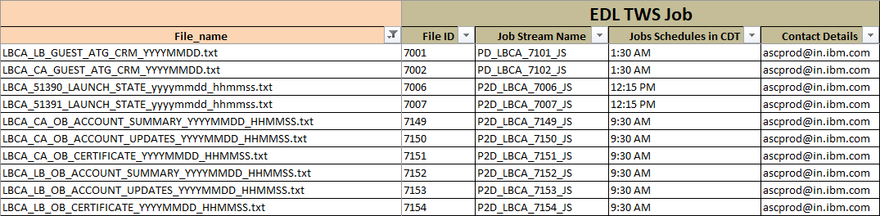

Figure - File and Data Orchestration - EDL TWS Job

# Security and Access Control

* Access to EFT Servers and Directories – Jobs that initially send source files to the EFT Servers and Directories must have appropriate read/write access. The EFT team maintains this.
* Access to Hygiene Server and Directories – Control-M Jobs that execute hygiene code must have appropriate read/write access to the Hygiene Server and Directories required to execute the process. This access is discussed further in the “Hygiene Processing - Operation Manual.docx” document (linked later in this document).
* SFTP Access to EDL Edge Node – The EFT jobs that ultimately transmit the source files to the EDL edge node should be using the following connection details:
  + Prod
    - IP Address: 169.61.94.13
    - Port: 22
    - Username: ascsftp
    - Password: <Found in EDL KeePass database>
  + Non-Prod
    - IP Address: 169.48.245.4
    - Port: 22
    - Username: ascsftp
    - Password: <Found in EDL KeePass database>

# Program Configuration

EFT transmission to the EDL Edge Node can be configured/reconfigured in the following aspects. **NOTE:** Some EFT jobs are shared by multiple source files. You should review the “EFT Transmission to Edge Node - File and Data Orchestration.xlsx” spreadsheet closely to make sure you understand the impact before requesting a change to any jobs.

| Configuration Option | Method to Configure |
| --- | --- |
| Schedule | Request Changes to the EFT, Control-M, GIS, and/or TWS jobs |
| Location and /or Name of directories on the Edge Node | Request Changes to the EFT, Control-M, GIS, and/or TWS jobs |
| Introduce Hygiene Processes to Existing File | Request changes to EFT jobs. Create new Control-M jobs. Create new EFT to EDL jobs. |
| Name of source files | Request Changes to the EFT, Control-M, GIS, and/or TWS jobs |

Table - Configuration Options

# Configuration Management

## Code Repository

* All code for EFT jobs is maintained by the EFT team; it is not the responsibility of the EDL support team.
* All code for Control-M jobs used to initially send files to the EFT server is maintained by the production control team; it is not the responsibility of the EDL support team.
* All code executed by Control-M jobs for Hygiene processes is stored in a code repository. This information is included in the “Hygiene Processing - Operation Manual.docx” document (linked later in this document).
* All code executed by TWS jobs is maintained by the IBM prod support team; it is not the responsibility of the EDL support team.

## Backup and Restore Procedures

All backup and restore procedures would be documented by the responsible teams (EFT, Production Control, IBM Prod Support) and would be outside the scope of this document.

Only exception would be hygiene processes, which are supported by the EDL team. The backup and restore procedures for hygiene processes will be included in the “Hygiene Processing - Operation Manual.docx” document (linked later in this document).

# Monitoring and Alerting

## Daily Operational Monitoring and Alerting

* EFT Jobs – No alerts currently exist for EFT jobs (neither “Transfer to EFT Server” jobs, nor “EFT to EDL Edge Node” jobs)
* Control-M Jobs (internal push) – All control-M jobs used for the initial internal push to the EFT servers have email alerts that cover job failure , or absence of expected file. These alerts are sent to the [aBS-IT-EDL-Support@AscenaRetail.com](mailto:aBS-IT-EDL-Support@AscenaRetail.com) distribution list.
* Control-M Jobs (for Hygiene) – All control-M jobs used for hygiene have email alerts that cover job failure, or absence of expected file. These alerts are sent to the [aBS-IT-EDL-Support@AscenaRetail.com](mailto:aBS-IT-EDL-Support@AscenaRetail.com) distribution list.

## Error Messages

* EFT Jobs – Any error messages or logs produced by the EFT jobs can be provided by contacting the EFT team (contact details later in this document).
* Control-M Jobs (internal push) – All control-M jobs used for the initial internal push to the EFT server have email alerts that cover job failure, or absence of expected file. These email alerts include error messages encountered during the execution. Further error information may be obtained by contacting the Ascena Operations Team (contact details later in this document).
* Control-M Jobs (for Hygiene) – All control-M jobs used for hygiene have email alerts that cover job failure, or absence of expected file. These email alerts include error messages encountered during the execution. Further error information may be obtained by contacting the Ascena Operations Team (contact details later in this document).

## Health Checks

A management dashboard has been developed to show EDL health and history for data flowing into the EDL. This is the URL for the dashboard: <http://l00dlmfeapp01.corp.local:8550/signin>

Below is a screen shot of the dashboard that shows the high level view of the dashboard with examples of current issues (red blocks).

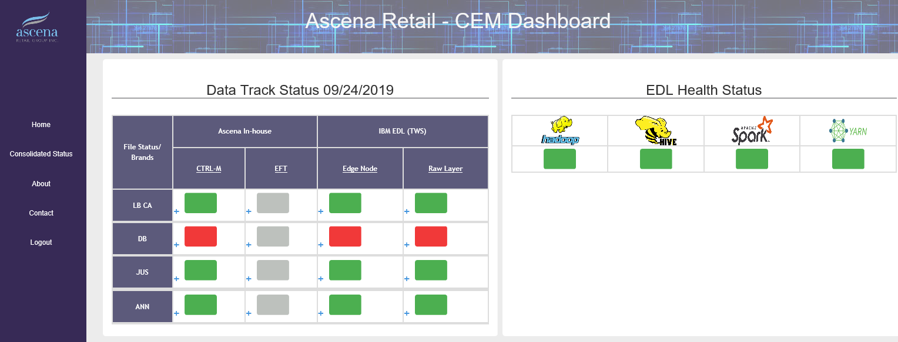

Figure - Example of Management Dashboard

Below is a screen shot showing a drill in view of the dashboard that displays the files in error.

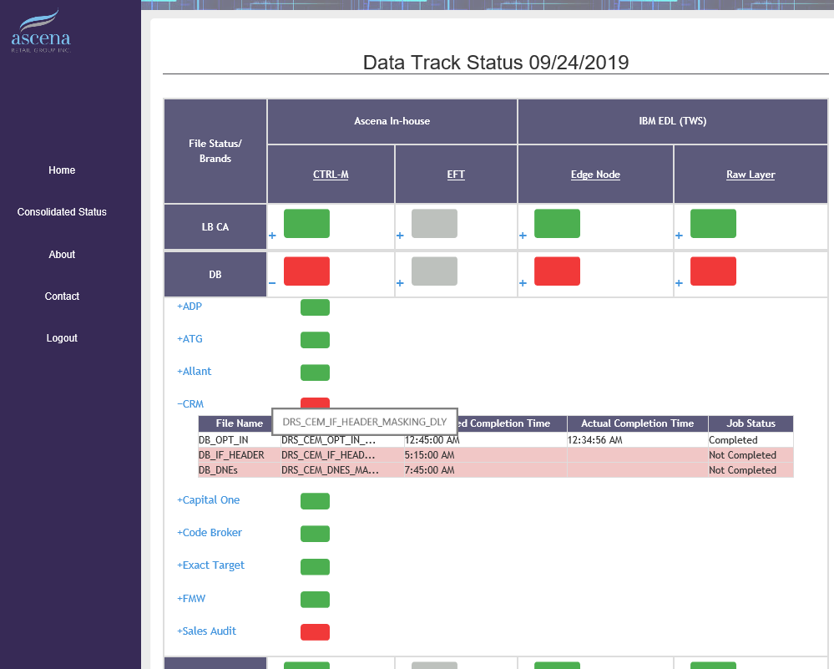

Figure - Example of Management Dashboard Drill In

# Operational Tasks

## Deployment

* EFT Jobs – To request new jobs or changes to existing jobs, you can use the “EFT Transmission to Edge Node - EFT Job Setup Requirements.xlsx” spreadsheet and log a request to the EFT team.
* Control-M Jobs – To request new jobs or changes to existing jobs, you can use the “EFT Transmission to Edge Node - Control-M Job Setup Requirements.xlsx” spreadsheet and log a request to the production control team.
* TWS Jobs – To request new jobs or changes to existing jobs, you should consult the “Data Ingestion to EDL Staging with IBM DIP - Operation Manual.docx” document for further information.

# Failure and Recovery Procedures

## Troubleshooting

* EFT Jobs – Follow up with the EFT team to troubleshoot any issues with EFT jobs. This may include issues where a file has not been delivered or has been delivered late.
* Control-M Jobs (for Internal Push) – Follow up with the Operations Team to troubleshoot any issues with the Control-M jobs for initial internal push to the EFT server. This may include issues where a file has not been delivered or has been delivered late.
* Control-M Jobs (for Hygiene) – To troubleshoot issues with the Control-M jobs used for hygiene inspect any error message produced by the Control-M jobs or output to log files. Review the “Hygiene Processing - Operation Manual.docx” document for further details.

# Contact Details

| Contact | Role | Email | Phone |
| --- | --- | --- | --- |
| EFT Team | Maintains and monitors all EFT jobs to transmit files to the EDL | SSG-APP-EFT-Support@AscenaRetail.com | N/A |
| Production Control Team | Maintains all Control-M jobs to transmit files to/from the Hygiene Server | [IT-Enterprise-ProductionControl@AscenaRetail.com](mailto:IT-Enterprise-ProductionControl@AscenaRetail.com) | N/A |
| Operations Team | Monitors all Control-M jobs to transmit files to/from the Hygiene Server | [AscenaOperations@AscenaRetail.com](mailto:AscenaOperations@AscenaRetail.com) | N/A |
| IBM Prod Support Team | Maintains and monitors all TWS jobs | [ascprod@in.ibm.com](mailto:ascprod@in.ibm.com) | N/A |
| EDL Support Team | Monitors and Maintains all Hygiene processes | [aBS-IT-EDL-Support@AscenaRetail.com](mailto:aBS-IT-EDL-Support@AscenaRetail.com) | N/A |

# Additional Document References

| # | Document Name | Document Link | Notes |
| --- | --- | --- | --- |
| 1. | EFT Transmission to Edge Node - File and Data Orchestration.xlsx | <http://epm01/sites/IT_Sites/EnterprisData_Lake_Operations/Shared%20Documents/Operation%20Manuals/EFT%20Transmission%20to%20Edge%20Node%20Documents/EFT%20Transmission%20to%20Edge%20Node%20-%20File%20and%20Data%20Orchestration.xlsx> | This spreadsheet contains a list of ALL files transmitted to the EDL edge node along with details on the EFT jobs, Control-M jobs, Hygeine processes, and TWS jobs associated. **It is the primary external documentation for this operation manual.**  **NOTE:** Some EFT jobs are shared by multiple source files. You should review the spreadsheet closely to make sure you understand the impact before requesting a change to any jobs. |
| 2. | EFT Transmission to Edge Node - Process Flow Diagram.vsdx | <http://epm01/sites/IT_Sites/EnterprisData_Lake_Operations/Shared%20Documents/Operation%20Manuals/EFT%20Transmission%20to%20Edge%20Node%20Documents/EFT%20Transmission%20to%20Edge%20Node%20-%20Process%20Flow%20Diagram.vsdx> | This diagram outlines the steps that a file takes in order to land on the EDL edge node in order to prepare it for ingestion to the staging database in Hive. This diagram is a visual companion to the textual spreadsheet “EFT Transmission to Edge Node - File and Data Orchestration.xlsx” |
| 3. | EFT Transmission to Edge Node - EFT Job Setup Requirements.xlsx | <http://epm01/sites/IT_Sites/EnterprisData_Lake_Operations/Shared%20Documents/Operation%20Manuals/EFT%20Transmission%20to%20Edge%20Node%20Documents/EFT%20Transmission%20to%20Edge%20Node%20-%20EFT%20Job%20Setup%20Requirements.xlsx> | Used to request new EFT jobs or changes to existing EFT jobs. Includes connection details for prod and non-prod edge nodes. |
| 4. | EFT Transmission to Edge Node - Control-M Job Setup Requirements.xlsx | <http://epm01/sites/IT_Sites/EnterprisData_Lake_Operations/Shared%20Documents/Operation%20Manuals/EFT%20Transmission%20to%20Edge%20Node%20Documents/EFT%20Transmission%20to%20Edge%20Node%20-%20Control-M%20Job%20Setup%20Requirements.xlsx> | Used to request new Control-M jobs or changes to existing Control-M jobs for Hygiene processes. |
| 5. | Hygiene Processing - Operation Manual.docx | <http://epm01/sites/IT_Sites/EnterprisData_Lake_Operations/Shared%20Documents/Operation%20Manuals/Hygiene%20Process%20-%20Operation%20Manual.docx> | Details the hygiene processes run against source files |
| 6. | Data Ingestion to EDL Staging with IBM DIP - Operation Manual.docx | <http://epm01/sites/IT_Sites/EnterprisData_Lake_Operations/Shared%20Documents/Operation%20Manuals/Data%20Ingestion%20to%20EDL%20Staging%20with%20IBM%20DIP%20-%20Operation%20Manual.docx> | Details the data ingestion processes to the EDL using IBM’s DIP process |
| 7. | EDL KeePass Database Location | X:\EDL\KeePass_DB\EDL_KeePass_db.kdbx | Allows for storage and sharing of passwords for all critical EDL accounts |

# Appendix